**Brooklyn torah gazette**

**For parshas Behar-bechukosai 5781**

Volume 5, Issue 36 (Whole Number 236) 19 Iyar 5781/ May 1, 2021

**Printed L’illuy nishmas Nechama bas R’ Noach, a”h**

For a free subscription, please forward your request to [***keren18@juno.com***](mailto:keren18@juno.com)

Past emails can be found on the website **ShabbosStories.com**

**Thousands of Israelis From all Sectors Rally to Assist Meron Victims**

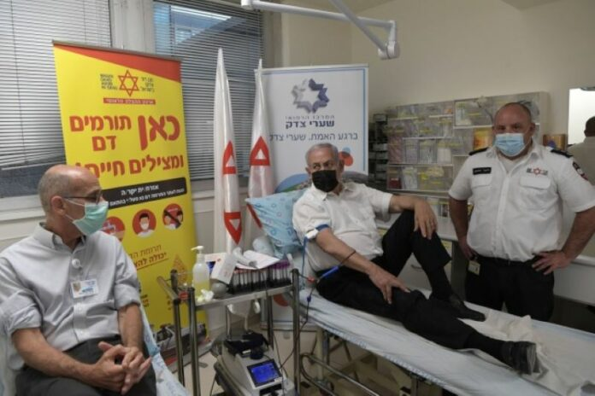

**Prime Minister Binyamin Netanyahu and Shaare Tzedek Medical Center Director-General Prof. Ofer Merin donate blood for Meron patients. (Kobi Gideon/GPO)**

Israelis of all sectors, Jews, Arabs, and Druze, religious and secular, mobilized to assist the victims and their families of one of the worst peacetime disasters in religious history, Ynet reported.

Long lines formed outside Magen David Adom stations across Israel after the organization called to the public to donate blood, especially type O.

So many Israelis showed up, including hundreds of people in Tel Aviv, that people were turned away and told to return on Sunday. People waited for hours in the hot sun to donate blood.

**Thousands of Israelis Donated Blood**

However although 2,208 Israelis donated blood on Friday, including Prime Minister Binyamin Netanyahu, more blood is needed and Magen David Adom has asked the public to continue donating blood in the coming weeks since blood units must be used within 35 days.

Organizations, private groups and city councils issued offers of assistance, including providing accommodations and food and reciting Tehillim. Residents of the north published offers on social media to accommodate any travelers stranded in the north for Shabbos.

Also, the Chatzor HaGlilit Regional Council established a special municipal center to provide accommodation for travelers stranded in the north of Israel over Shabbos.

Residents of the Druze villages of Yarka Beit Jen and Yanuh-Jat and residents of Arab villages in the Meron area offered accommodations to travelers in their homes or hostels. Arab and Druze villages set up refreshment stations at nearby junctions with kosher food, drinks, and fruit for the thousands of people traveling from Meron to the center of the country.

“Our hearts go out to the families of those killed in the disaster on Mount Meron and we pray for the recovery of the wounded,” said Sheik Mowafaq Tarif, the spiritual leader of the Druze community in Israel. “There is great sadness when you hear the news about a terrible event. All citizens of the country share in the pain of the loss.”

**Non-Jewish Druze Affected by the Tragedy at Mount Meron**

“The members of the Druze community and the Druze villages share in the grief of the families who lost their loved ones, and are ready and willing to provide any help in the Mount Meron area.”

Volunteers of Lev Chabad, an organization that assists patients and their families in hospitals, distributed food to the families of those killed and injured at Meron.

Lev Chabad members preparing food for victims’ families. (Photo: Lev Chabad)

An optical store in Ramla offered free replacement glasses to anyone who lost theirs in the disaster.

“Our hearts go out to the families of those killed and injured,” said Hadar Miller, senior optometrist at Opticnet Barens. “There is nothing to obscure the pain, but we have decided to do everything to alleviate it even a little bit. We invite the affected families and those whose glasses were destroyed following the disaster to come to the store and get new glasses at no cost.”



**Broken glasses are seen at the site where fatalities were reported during Lag BaOmer festival at Mt. Meron in northern Israel, Friday, April 30, 2021. A stampede at the religious festival attended by tens of thousands of ultra-Orthodox Jews in northern Israel killed dozens of people and injured more than 100 others early Friday, medical officials said, in one of the country’s deadliest civilian disasters. (AP Photo/Sebastian Scheiner)**

A restaurant in Givat Shmuel offered free prepared meals of Mehadrin food “with great love” for the families of victims who couldn’t prepare for Shabbos.

The above is only a partial list of the generous assistance offered to victims and their families.

*Reprinted from the May 2, 2021 website of Yeshiva World News.*

# Rav Avigdor Miller on

# What and How to Eat



**QUESTION:** **Should a person eat meat every day?**

**ANSWER:** Now, that’s not my line – I’m not in the nutrition business.  But I’ll merely say this: In addition to having a varied diet all kinds of food, not only one kind, in addition to that, everyone should learn not to be a slave to the dinner table.  We eat for the purpose of being healthy. The Rambam says that you should eat what’s good for your health.  He says, lo k’kelev u’kechamor, not like the dog or the donkey who eat only what’s sweet for them.  Animals eat what’s sweet to them but we have to eat what’s good for us.

And therefore that’s the only recommendation I’m able to give: Eat what’s healthful for you and it will be included in your service of Hashem if you’ll add the thought of why you’re doing it. Like it says in the Shulchan Aruch. The Shulchan Aruch says you should eat with the intention, kedai she’uchal la’avod es Hashem, so that I should have the strength, the energy, to be able to serve Hashem.

Always think that.  I would recommend that you should say it too when you start eating. It’s not a bad idea, only that your wife shouldn’t hear it – she’ll laugh at you. Or your husband will laugh at you. But you should say it anyhow, even if they’ll laugh: “I’m going to eat now kedai she’uchal la’avod es Hashem.” That’s what the Shulchan Aruch says.  You’re eating in order to serve Hashem.

*Reprinted from the May 2, 2021 email of Toras Avigdor. Adapted from Tape #751.*

**Rabbi Berel Wein on**

**Parshat Behar-Bechukotai 5781**

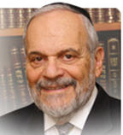

The reading of these two sections of the Torah concludes the book of Vayikra – the book that contains most of the commandments given to the Jewish people on Sinai and for all eternity. One of the central commandments that appears in this week's reading is that of shmita – the rules regarding the sabbatical year that the Jewish people were to observe when they were in the land of Israel. This commandment, in many of its forms, remains viable today, at least as a rabbinic ordinance.

There is discussion that as the present Jewish population here in the land of Israel continues to grow and expand, there is a possibility that this sabbatical year ordinance will revert once again to its original status as a Torah commandment. But even in its present circumstance, as a rabbinic ordinance, it has strong influence over the everyday life of citizens of the State of Israel.

Special arrangements must be made regarding agricultural produce grown in the Holy Land in this sabbatical year, and various ways have been found to enable the agricultural economy to continue to function according to Jewish law and tradition, even during the sabbatical year.

But the idea behind the sabbatical year remains fixed in the minds and hearts of the Jewish people wherever they may live. And that basic idea is simple: that the world and all its land belongs to and is subject to the will of the Creator, and that human beings are only temporary trustees over the land.

One of the most difficult ideas to for people to accept is that life itself is transitory and temporary. We pretend we will be here forever and we live our lives accordingly, even though we are all aware of our mortality and the transient nature of human existence. We are always saving for tomorrow, even when we are quite old and advanced in years, and logically, really do not need to save for a tomorrow that, deep down in our hearts, we know we may never see.

We involve ourselves in future projects that can only benefit future generations, because we believe that somehow that future benefit and achievement will accrue to our credit when heaven balances the books, so to speak. It is this contradictory nature of human beings, to plan for a future that instinctively one knows one will not actually witness in this world, that really fuels all human progress and is the basis for the advancement of civilization over the ages.

All of this is based upon the realization that the sabbatical year imposes upon us, that there is no permanence for anything, and what we do achieve does not permanently belong to us. We are merely temporary custodians of the riches of the Almighty that He has bestowed upon his creatures in this world. This is really the sublime and internal message that the sabbatical year, with all its laws, ordinances, and adjustments, imposes upon us, and makes it a year of renewal and uniqueness.

*Reprinted from the current website of Rabbiwein.com*

**Parshas Bechukosai**

**If You Will Labor**

**In Torah Study**

**By Rabbi Bentzion Shafier**

**Founder of TheSmuz.com**

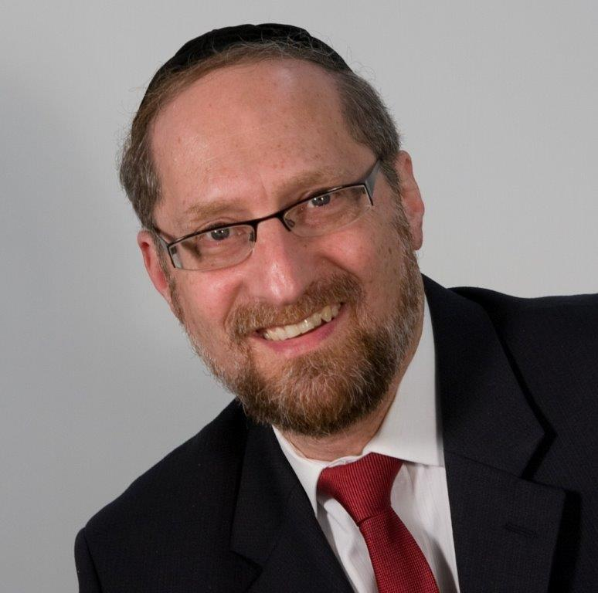

“*If you will follow My decrees and observe My commandments and perform them*. . .” — VaYikrah 26:2

The Torah lays out two divergent destinies for the Jewish people: “If you will go in the ways of my statues. . . I will give you rainfall in its time, the land will give forth with abundance, the trees of the field will produce fruit…you will eat until you are satisfied. . . There will be peace in land...”

However, “if you do **not** guard my statutes . . . you will suffer diseases and famine. . . you will plant and not harvest. . . your enemies will chase you. . . the skies will turn to iron. . . wild animals will attack . . . [and finally,] an avenging sword will come into the land.”

.

Rashi explains that the pivotal point of these two paths is: If you will labor in Torah, then you as a nation will find great success. Your enemies will fear you, and you will rise ever higher. If, however, you cease to labor in Torah study, then curses will befall you. In short, our success or failure as a nation hinges upon this one activity.

However, as Rashi also points out, this concept of **laboring in Torah study** is not found in the posuk. The words are, “If you will go in the ways of my statutes.” Nowhere does it specify what this refers to. Rashi explains that it cannot refer to keeping the mitzvahs because that is specifically mentioned at the end of the posuk. So by process of elimination, he reasons that this must be referring to laboring in Torah study.

This Rashi is difficult to understand. There seems to be no indication of the concept in the posuk. Granted, learning Torah is very significant, and we may know from other sources that laboring in Torah study is central to serving HASHEM, but there doesn’t seem to be any indication **here** that this statement is speaking about laboring in Torah study. How does Rashi know that this statement of, ”If you will go in the ways of mystatutes,” refers to laboring in Torah study, as opposed to any other mitzvah?

**The Inner Workings of the Human**

The answer to this question stems from understanding the inner nature of man. The Chovos Ha’Levovos (Shaar Avodas Elokim) explains that HASHEM created man from two very distinct elements. Part of man is pure intellect and wisdom. This part of the person only wishes to do that which is noble and proper. It desires to be generous and giving. It needs to do that which is good and right. This part deeply hungers to experience HASHEM. Chazal call this segment the “Nefesh Ha’Sichili” – the pure soul.

However, there is another component of the human personality that is pure instinct and desire. That part of the individual doesn’t care about anything but fulfilling its needs and wants. It is comprised of base appetites and inclinations. This is referred to as the “Nefesh Ha’Bahami” – the animal soul.

**The Human is in a Constant State of Flux**

When HASHEM created man, He took these two diverse segments and mixed them together, creating a new synthesis called man. Man has two competing sides to him, each one crying out to fulfill it needs, each one demanding its fill. These two elements are in competition for dominance of the person. Much like a muscle that grows stronger with use and atrophies with disuse, each side is constantly being strengthened or weakened.

If a person gives in to his animal instincts, those instincts become stronger and more dominant. If a person listens to his spiritual soul, it becomes stronger, gaining primacy over his personality. The human is in constant flux, with one side or the other always growing, always gaining supremacy and control over the person.

Man was put on this planet to grow. By resisting the pull of the animal soul and allowing the pure soul to flourish, man elevates himself and reaches the state of perfection of which he is capable. On the other hand, if he gives in to the cries of the animal soul, he elevates it, allowing it to take control of him. His appetites become stronger and dominate him until they effectively rule over him. He becomes more animal than man.

**The Torah: the Ultimate Guide for Self-Perfection**

The Torah, which is the ultimate guide of human perfection, warns us against certain activities that give an unusual advantage to the Nefesh Ha’Bahami. These are the sins as outlined in the Torah. We are cautioned to avoid certain foods, and we are warned against certain activities because they give an unfair edge to the animal soul.

However, any activity that a person engages in strengthens one side or the other. When a person eats, sleeps, works, or goes about all of his daily activities, these physical actions strengthen the Nefesh Ha’Bahami. In a sense, there is an unfair lead given to the animal soul. All day long it is in its element, and by being utilized, it is thereby strengthened.

To bring balance to the equation, HASHEM gave us specific mitzvos to nourish the Nefesh Ha’Sichili. The single greatest nutrient of the nishomah is learning Torah. For the nishomah, Torah is like rocket fuel. When a person learns Torah, his nishomah is strengthened and invigorated. It becomes fortified and then takes the lead in the battle against the Nefesh Ha’Bahami. However, without it, the nishomah doesn’t stand a fighting chance because the animal soul is so much more in its element in this world.

This seems to be the answer to Rashi. Since this expression, “If you will go in the ways of my statutes**”** is the pivotal point of the Jewish people’s destiny, it must be referring to that element that is the key to the equation: **laboring in Torah study**. Therefore, Rashi points this out almost as the translation of the words.

There is a great lesson for us in this concept. The Jewish people is never stagnant. We are either going up towards great heights or down to the lowest abyss. The single greatest nourishment for the soul of the individual, and therefore for the soul of the nation, is laboring in Torah study. If we engage in it, support it, and actively pursue it, we will flourish as a people and enjoy unparalleled success. If not…

*Reprinted from the website of Theshmuz.com.*

**The Humility of Mount Sinai**

**And the Jew’s Reason**

**For Observing Mitzvot**

**From the Talks of the Lubavitcher Rebbe**

**Rabbi Menachem Mendel Schneerson, Zt”l**

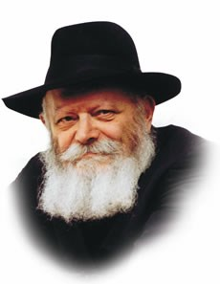

The name of the first of this week's two Torah portions, Behar, means literally "on the mountain." The Midrash relates that when G-d wanted to reveal His holy Torah to the Jewish people, all the mountains in the world vied for the privilege.

Each mountain in turn came before G-d and boasted of its superiority and beauty, yet it was precisely Mount Sinai -- a small and unassuming mountain that refused to boast -- upon which G-d chose to give the Torah.

Neither the mountains' impressive height, prime location or other physical characteristics were taken into consideration. Not only did these features not convince G-d, as it were, to choose them, but their boasting had the opposite effect. For the Torah could only be given in a place where side issues were irrelevant; the Torah was revealed purely for its own sake.

The giving of the Torah on humble Mount Sinai contains a lesson for all of us in how a Jew is supposed to observe G-d's commandments.

Personal considerations and motivations, no matter how valid or convincing, are not the real reason we perform mitzvot. Rather, a Jew fulfills the Torah's commandments solely because such is the will of G-d.

Nor do we perform mitzvot because of their reward, despite the fact that the Torah promises ample dividends for our compliance. True, we will be more than compensated, but the true reason a Jew obeys G-d's will is only because He wants us to. Some Jews may wish to observe the commandments in order to merit Gan Eden, but this too, is only a secondary issue. Observing mitzvot brings delight to the spirit, refines our character attributes and purifies the soul, but the desire to obtain these personal benefits is not the Jew's genuine motivation.

As Jews we are obligated to emulate the example of Mount Sinai, the only proper "vessel" for containing the Torah. Our motivation and intent in heeding G-d's word must be unadulterated by thoughts of personal gain or advantage. For the true reason we serve G-d and obey His mitzvot is solely for the sake of serving Him.

In fact, had G-d commanded us to perform actions which would not be rewarded, we would carry out His will with the same joy, enthusiasm and vitality with which we observe the Torah commandments, solely because He wants us to!

*Reprinted from the 5756/1996 Behar-Bechukotai edition of L’Chaim Weekly. Adapted from Likutei Sichot of the [Lubavitcher] Rebbe, Vol.1.*

**A 19th Century Yerushalayim Custom for Erev Shabbat**

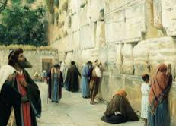

R’ Moshe Nussbaum/Reisher z”l, best known as the author of Mishlei Yaakov, a collection of the teachings of the Dubno Maggid z”l, grew up in Yerushalayim in the mid-1800s.

Around 1868, he traveled to Europe as a fundraiser, and there he wrote Sha’arei Yerushalayim–a sort of guide book combining Talmudic teachings about Eretz Yisrael with his own experiences in, and observations of, the Holy Land. The following is an excerpt:

There is a beautiful custom in the holy city of Yerushalayim to go on Erev Shabbat (Friday) to go to the place of our Holy Temple, i.e., the Kotel, from which the Shechinah never departed, after having immersed in the mikvah and donned white garments.

Upon arriving there, they prostrate themselves and bow humbly and recite the verse (Bereishit 28:17), “How awesome is this place! This is none other than the abode of G-d and this is the gate of the heavens.”

Four amot [6-8 feet] away, they remove their shoes; then they approach the wall, the support for our Holy Temple, and kiss the holy stones very lovingly, but at the same time enveloped in trepidation and awe. They recite Shir Ha’shirim, also Tehilim, until completion, in order to extricate the rose from the thorns [see Shir Ha’shirim 2:2].

Then they pray minchah with a humble spirit, and each one recites a prayer for his relatives in the Diaspora. Then they go to shul for Kabbalat Shabbat, though some remain there to welcome Shabbat with song; most of them are Sephardim. Some go there every day after their prayers to recite supplications. It’s customary in Yerushalayim to go on every Erev Rosh Chodesh to the burial place of our matriarch Rachel–a two-hour journey–and to spend the night.

This is done all year long, as well, and especially on her yahrzeit, 11 Marcheshvan. At night, the entire book of Tehilim is recited, word-by-word, in a pleasant tune. Everyone prays for himself, his household and his family, and writes his name on a piece of paper and leaves it there.

They also light many oil lamps. In the morning, they pray with a minyan, kiss the monument, and go their way in peace. The stone which Yaakov Avinu a”h placed there as a monument, as is written in the Torah (Bereishit 35:20), stands there to this day, approximately five amot [7.5-10 feet] tall and six amot [9-12 feet] long and covered in plaster.

*Reprinted from the Parshat Behar-Bechukotai 5781 email of whY I Matter, parshasheet of the Young Israel of Midwood in Brooklyn as edited by Reb Yedidye Hirtenfeld.*